LangChain vs. LangGraph
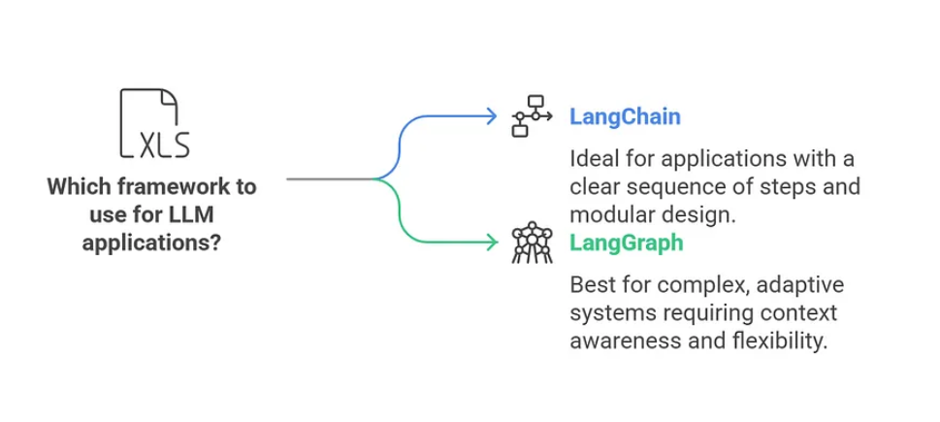
What is LangChain?
LangChain is a framework that helps you connect multiple operations together like a pipeline—each step feeds into the next. This is especially useful when working with Large Language Models (LLMs) for tasks like summarizing documents, answering questions, and more.

Think of it like a pipeline:
Let’s say you’re building an app to:
- Retrieve data from a website.
- Summarize that data.
- Answer user questions using the summary.
LangChain helps you structure this process as a sequence of steps (also called a “chain”), where:
- Step 1 feeds into Step 2,
- Step 2 feeds into Step 3,
- And the final output is what your user sees.

Why LangChain is Powerful
- Modular: You can plug and unplug components easily.
  - Example: Use GPT-4 for answering and Gemini for summarizing.
- Customizable: You control the flow. Want to add translation or sentiment analysis between steps? Just add another block!
- Scalable: You can build from simple workflows to complex multi-step logic.

When Should You Use LangChain?
- When your task has a clear step-by-step structure.
- When you want to combine different tools or models.
- When you need context retention, like in conversations (using memory components).

LangGraph: Building Smart, Stateful Systems

What is LangGraph?
LangGraph is a specialized tool in the LangChain ecosystem made for nonlinear, stateful workflows. While LangChain is like a straight road (step-by-step), LangGraph is more like a map with multiple paths and loops, perfect for building smart assistants or multi-step reasoning agents.

How It Works
Instead of chaining one task after another, LangGraph represents your app as a graph:
- Each node is a task or decision (e.g., Add Task, Summarize Tasks).
- Each edge defines how the app moves between tasks.
- A shared state keeps track of all data across steps — this is what gives LangGraph its memory and flexibility.

Example: Task Management Assistant
Imagine a virtual assistant that:
- Takes user input
- Adds new tasks
- Marks tasks as complete
- Summarizes all tasks
LangGraph:
- Has a "process input" node to understand what the user wants.
- Routes it to nodes like “Add Task” or “Complete Task”.
- Uses a state object to remember all current tasks.
- Loops back when needed (e.g., user adds multiple tasks).
This flexibility lets the assistant respond to changing input and context.
LangChain vs. LangGraph

Feature | LangChain | LangGraph
Design Style | Linear pipelines (e.g., A → B → C) | Graph of actions (with loops and branches)
State Management | Limited; info passed step to step | Powerful; shared state across all nodes
Control Flow | Fixed order only | Flexible: loops, branches, conditions
Use Cases | Sequential apps (summarizers, RAG, Q&A) | Multi-agent systems, assistants, chatbots with memory
Components | Chains, agents, memory, LLMs | Nodes, edges, state
Revisiting Steps | Not supported | Fully supported

Which One Should You Use?

Scenario | Tool to Choose
Simple Q&A, RAG, or summarization | LangChain
Virtual assistant with memory | LangGraph
Fixed steps and tasks | LangChain
Adaptive, branching decisions and task cycles | LangGraph

